Tango Web Service: customized CMMS link
In the Integrated Condition Status Report, users can reference a maintenance work order generated in response to a condition problem. This can be entered through a manual process, where the maintenance planner views the integrated condition results, generates a work order with a CMMS, and then copies the work order reference number into the ICSR field. When the work order is closed the planner would execute the ICSR ‘Checkoff’ and paste in work order summary information.
24/7 Systems has defined an optional ICSR/CMMS link that can be customized for a plant’s specific CMMS implementation with systems such as SAP, Oracle, or JD Edwards. When this option is implemented, the general operation would be as follows:
- From the Integrated Condition Status Report (ICSR) an authorized user would make the decision that a ‘Work Order Request’ or ‘Work Order’ is needed (depending on whether the customized interface is set up to make work requests or generate work orders, or both), he would click ‘CMMS’ beside the appropriate item in the ICSR. This will send the content of the condition entry to the CMMS system, such as analysts name, case number, and findings and recommendations. Depending on the specifications of the customized interface, this could generate a work request or post the information to a work order awaiting an authorized CMMS user to complete and approve the transaction.
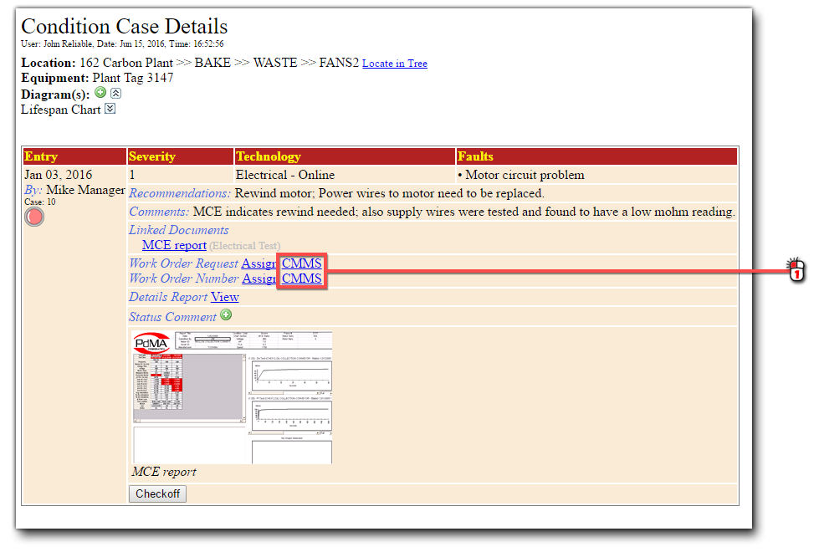

- Once the work order is generated in the CMMS, the reference number will be automatically transferred back to the ICSR work order number field, and show up in the work order number(s) column for that condition entry.
- On closure of the CMMS work order, information is automatically sent back to Tango to complete the ‘Checkoff’ function; this can include inserting text from the CMMS work summary in the ‘Checkoff memo field ‘ so that ICSR users can understand what work was done.

The following link provides some technical detail of the Tango specifications for the interface:
www.TF7.com/Concert/ConditionEntry.asmx

There is likely to be corresponding code development by the customer’s IT group so the CMMS will know how to handle the ISCR information; therefore 24/7 Systems, Inc. engineering would need to work with a customer’s IT group in order to finalize specifications and provide a quote for the engineering development. Also, keep in mind that any interface such as this is likely to require maintenance as either the CMMS or Tango change over time, and that maintenance will involve both the customer’s IT and 24/7 Systems engineering.

